Dias System Basics

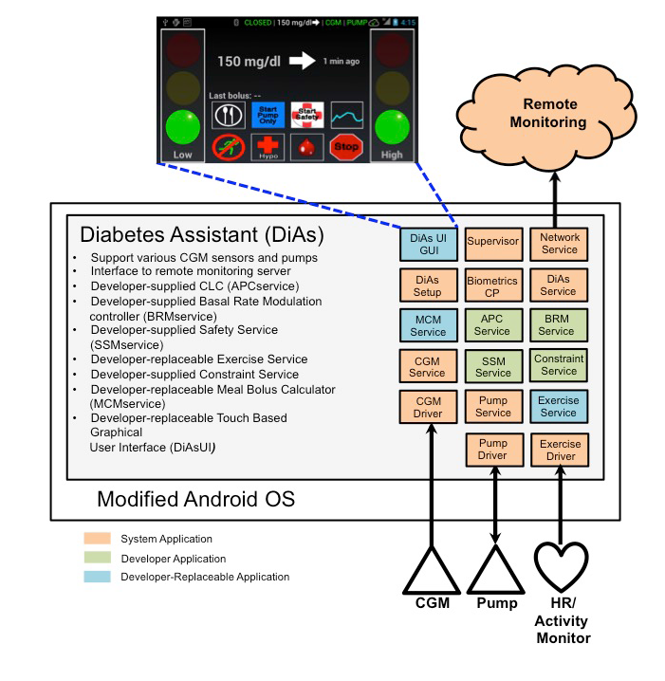

Remote Monitoring: via Network Service
- Send the information to University of Virginia servers
- System Application
- No access to source code/ no way to replace it
- No means to change this function

Exercise Service
- Data retrieve from Activity Monitor (Zephyr now! May be other device in future)
- Reads data from EXERCISE_SENSOR_TABLE (and possibly other system data)
- Saved in EXERCISE_STATE_TABLE
  - Check functions to write on t
- Developer-Replaceable Application
- We can play with it !!

Pump Service and Pump Driver
- Control pump communication
- Control insulin sent to pump
- System Application
- No access to source code/no way to replace it
- No means to change this function

BRM Service - Basal Rate Modulation Service
- Secondary Closed Loop controller that is activated according to a daily schedule
- Or it may be used to set an constraint on the minimum amount of insulin to be delivered by the APCservice.
  - No limitations found on its only file IOMain.java
- Calculates Green/Yellow/Red light
- Developer application
- We can play with it !!
  - storeUserTable1Data() -->Biometrics.USER_TABLE_1_URI

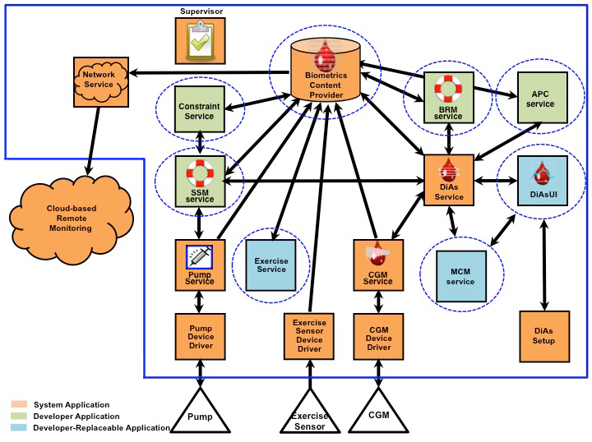

Communication between apps/processes/services:
- Broadcast Messages
- DiAs modules send broadcast Intents that all applications receive. .
- Another application registers a Broadcast Listener to receive particular. Broadcast messages
- Also used to report changes in the state of connected devices.
- Directed Messages –
- DiAs modules can also be bound to one another and send private messages back and forth between sender and receiver.
- I.e the Safety Service maintains a bound connection with the Pump Service.
- Central Database –
- Access to the DiAs SQLite database is controlled by the biometricsContentProvider
- CGM, insulin history, system status, SMBG, hardware and configuration data
- It also controls which modules have query, update, insert and delete access to individual database tables.
- Applications may use the Android ContentObserver class to receive notification and control when a particular database table is modified. This can be particularly useful in observing the database ‘cgm’, ‘insulin’ and ‘system’ tables for changes in system mode or device connectivity

Parameters - parameters.xml file
- Parameters used by core DiAs system functions
- Developers may add additional parameters
- Access these parameters from the central database
- It is the responsibility of the developer of the system which makes use of DiAs to modify parameters.xml appropriately for their application and to verify that the overall system – including interactions with parameters.xml – operates correctly.
- Some parameters:
  - allowed_modes - 4: Closed Loop Mode only.
  - safetyDistinctFromCL - true(Indicates whether Safety is considered as a distinct operating mode or a submode of Closed Loop)
  - blood_glucose_display_units - Controls units in which CGM and BG are displayed.
  - bolus_missed_threshold
  - apc_enabled
  - brm_enabled
  - tbr_enabled - Enable/disable Temporary Basal Rate functionality
  - temporaryBasalRateEnabled
  - Enable alarms

Configuration - configuration.xml file

SSMservice
The SSMservice is a developer-supplied application which examines all insulin requests for safety when the DiAs is operating in Closed Loop or Safety Only modes. DiAsService makes insulin requests to the SSMservice using a predefined software interface . The SSMservice then communicates insulin requests to the Pump Service using a second software interface
Insulin requests:
APCservice -> DiAsService -> SSMservice ->PumpService

